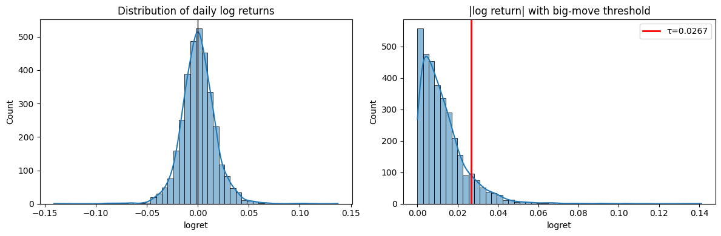
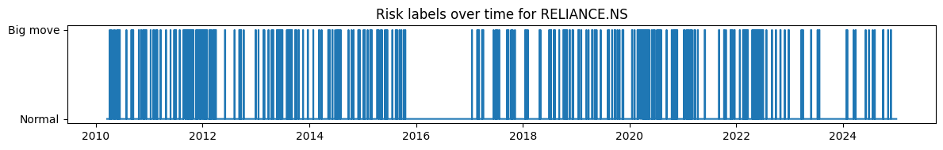
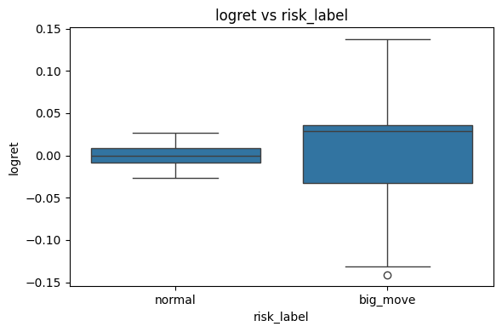
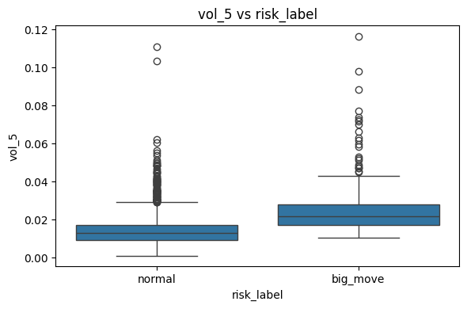
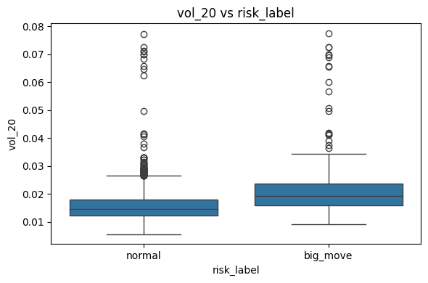
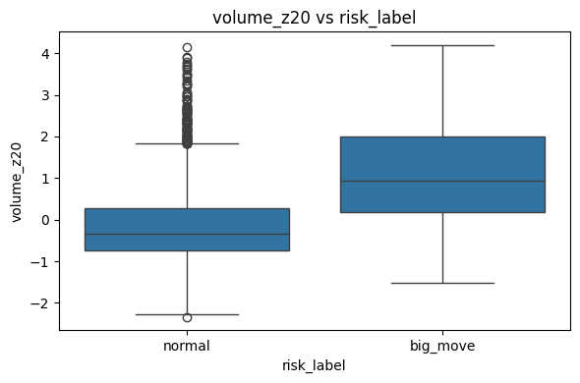
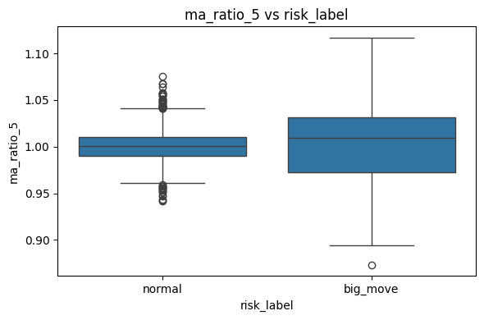
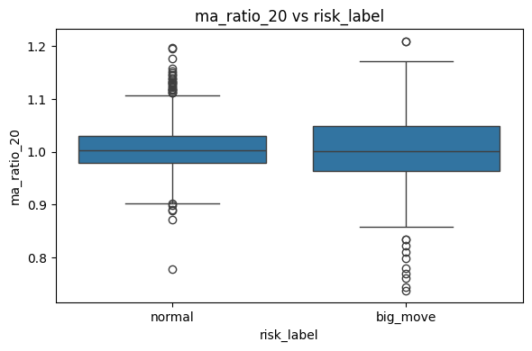
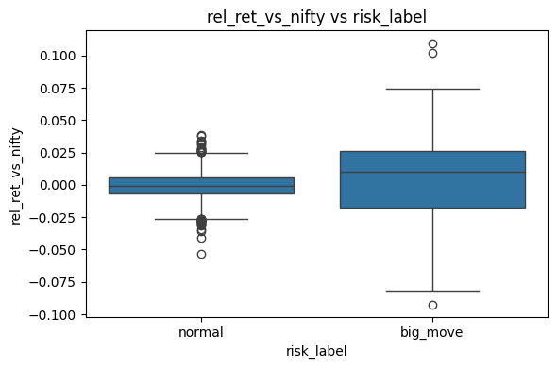
Feature means for normal vs big_move days:
 | normal | big_move
logret | 0.000026 | 0.004182
vol_5 | 0.014107 | 0.025275
vol_20 | 0.015667 | 0.021562
volume_z20 | -0.136509 | 1.139469
ma_ratio_5 | 1.000832 | 1.003489
ma_ratio_20 | 1.005772 | 1.003194
rel_ret_vs_nifty | -0.000575 | 0.005280
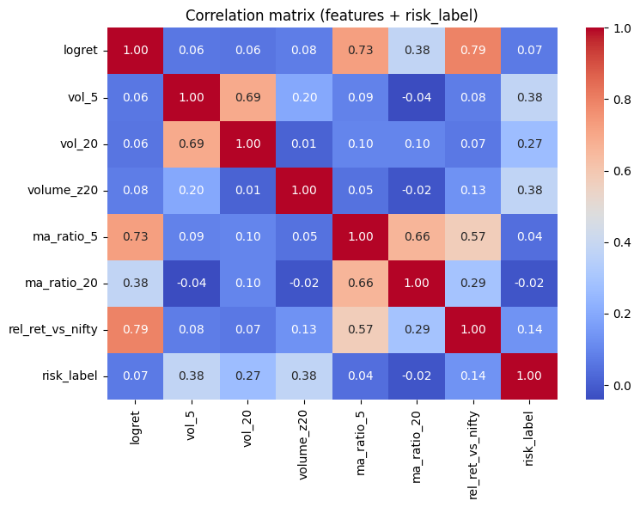

Short answer: yes, the model is picking up some signal, and your EDA output is actually very helpful. We can already see which features matter most for “big-move” (risk) days.

1. What your EDA table is telling us
You shared this summary of feature means for normal vs big_move days:
Feature | Normal | Big_move | What it means (intuitively)
logret | 0.000026 | 0.004182 | Average daily log return
vol_5 | 0.014107 | 0.025275 | 5-day realized volatility
vol_20 | 0.015667 | 0.021562 | 20-day realized volatility
volume_z20 | -0.136509 | 1.139469 | Volume z-score vs last 20 days
ma_ratio_5 | 1.000832 | 1.003489 | Price / 5-day moving average
ma_ratio_20 | 1.005772 | 1.003194 | Price / 20-day moving average
rel_ret_vs_nifty | -0.000575 | 0.005280 | Stock return – Nifty return
Key observations:
- Volatility & volume spike on big-move days
  - vol_5 and vol_20 are clearly higher on big-move days.
  - volume_z20 jumps from slightly below average (-0.13) to well above average (~+1.14). That’s a big separation in “z-score units”.
- Stock outperforms index on big-move days
  - rel_ret_vs_nifty goes from slightly negative to clearly positive.
  - So big moves are often “idiosyncratic” moves where the stock beats the index.
- Moving-average ratios are weak signals
  - ma_ratio_5 and ma_ratio_20 are both extremely close to 1 in both regimes.
  - Differences exist, but they’re tiny compared to volume/volatility differences.
- logret difference is expected but must be used carefully
  - Big-move days are defined using |logret| ≥ threshold, so of course its mean is larger.
  - That’s fine as long as the model only sees past log returns (lags) and not the label-defining day itself.

2. Which features should we keep?
For risk flagging, I’d prioritise features that show strong separation and have a good economic story:
High-priority features (definitely keep)
These should be part of your core feature set (with lags over the past T days):
- Short-term volatility: vol_5
  - Big moves happen after periods of increased short-term volatility.
- Medium-term volatility: vol_20
  - Captures more persistent “nervousness” in the stock.
- Relative volume: volume_z20
  - This is probably your single strongest feature in this table.
  - Big moves are preceded or accompanied by unusual volume.
- Relative performance vs index: rel_ret_vs_nifty
  - Tells you if the stock is already moving differently from the overall market.
- Past log returns (lags):
  - Not shown in the table, but we should use sequences of past logret as input.
  - Very natural for sequence models; we just need to be sure we are always predicting next day.
Medium-priority / optional (keep for now, remove later if needed)
- ma_ratio_5, ma_ratio_20
  - They don't separate very strongly, but they are cheap to keep.
  - Could be weak but helpful context for the RNN/CNN.
  - If later we want to simplify, these are candidates to drop first.
So, for the risk-only model, I would build windows that contain:
- last T days of:
  - logret
  - vol_5, vol_20
  - volume_z20
  - rel_ret_vs_nifty
  - (optionally) ma_ratio_5, ma_ratio_20
- possibly + index features (Nifty log returns, Nifty volatility) as extra channels.

3. What the EDA cells are doing (conceptually)
You asked what “the above cells” are doing and how they help with feature selection. Let’s walk through the logic of the EDA pipeline I gave you (even if your exact cell boundaries differ, this is the flow you followed):
Cell 1 – Download data & build features
What it does:
- Uses yfinance to download daily OHLCV for:
  - Your stock(s)
  - Indexes (e.g., Nifty50, Nifty IT)
- Creates engineered features:
  - logret: daily log return
  - vol_5, vol_20: rolling standard deviation of log returns
  - volume_z20: z-score of volume vs last 20 days
  - ma_ratio_5, ma_ratio_20: price / moving average
  - rel_ret_vs_nifty: stock return - index return
Why it’s helpful:
- This cell transforms raw prices into economically meaningful features.
- You cannot see structure by just looking at prices; you need returns, vol, volume, etc.

Cell 2 – Define “big_move” labels
What it does:
- Computes a threshold for “big moves”, usually:
  - threshold = np.quantile(|logret|, 0.9)
- Creates a binary label:
  - big_move = (|logret| >= threshold).astype(int)
- Prints counts: how many normal vs big-move days, percentage of 1’s.
Why it’s helpful:
- You now see how imbalanced the classification problem is (e.g., 10% positives).
- This defines exactly what “risk day” means in your project:
→ top 10% absolute daily moves in log return.

Cell 3 – Compare feature distributions for normal vs big_move
This is where your mean table came from.
What it does:
- Splits the data into:
  - normal = df[df.big_move == 0]
  - big = df[df.big_move == 1]
- Computes:
  - normal[features].mean()
  - big[features].mean()
- Possibly also:
  - Standard deviations (std())
  - Maybe t-tests / effect sizes (Cohen’s d)
Why it’s helpful:
- This immediately shows which features behave differently on big-move days:
  - Volume z-score much higher → strong candidate.
  - Volatility higher → good feature.
  - MA ratios almost identical → weaker feature.
- This is the main driver for our feature selection decision.

Cell 4 – Visual exploration (histograms / boxplots / KDE)
What it does:
- Plots e.g. for each feature:
  - Distribution for normal days vs big-move days.
  - Sometimes boxplots, violin plots, etc.
Why it’s helpful:
- Means alone can hide warnings:
  - Maybe there’s heavy overlap, or long tails.
- Plots show:
  - Is the separation robust or based on a few extreme outliers?
  - Are there weird anomalies or data quality issues?
Even if you didn’t save the plots in the doc, this is where you visually saw that volume/volatility shift right on big-move days.

Cell 5 – Correlation matrix / heatmap
What it does:
- Computes correlation matrix of:
  - features + [big_move]
- Plots a seaborn heatmap.
Why it’s helpful:
- Tells you if two features are almost duplicates:
  - e.g., vol_5 and vol_20 very correlated → okay, but we know they are similar.
- Shows which features correlate most with big_move:
  - Typically volume_z20, vol_5, rel_ret_vs_nifty will have higher |correlation|.

Cell 6 – Simple baseline model for feature sanity check (optional)
Sometimes we also add a quick baseline:
- Fit a simple logistic regression or shallow classifier on these features.
- Look at:
  - Accuracy / AUC / precision.
  - Feature coefficients / importance.
Why it’s helpful:
- If a simple baseline with these features performs worse than random, something is wrong:
  - Label definition?
  - Feature leakage?
  - Data alignment (off by one day)?
- If it’s a bit better than random, good: we at least have weak signal.

4. So… what next?
Given everything we’ve seen:
- Yes, using log returns for risk flagging is correct.
  - You’re now predicting probability of a large |logret| next day, not the price itself.
  - This is exactly aligned with “risk days” in your problem statement.
- Your features are not useless.
  - Volume z-score and volatility clearly differ between normal and big-move days.
  - Relative vs index also shows a decent shift.
- But the signal is weak, so no model will magically hit 90% precision.
  - Even in the best research, precision/recall improvements are often modest.
  - Your goal is now more realistic: show MSF-CAL is consistently better than the CNN-BiLSTM baseline, not perfect.

TL;DR: Recommended feature selection (for the next model)
For each day t (as part of a T-day window):
- Core features (must-have):
  - logret_t
  - vol_5_t, vol_20_t
  - volume_z20_t
  - rel_ret_vs_nifty_t
- Optional contextual features:
  - ma_ratio_5_t, ma_ratio_20_t
  - Index log returns / volatility (Nifty, Nifty IT, etc.)
Then we use these sequences over past T days to predict P(big_move at t+1).
If you want, next step we can:
- Define an explicit final feature list from your actual DataFrame columns.
- Plug that into your existing risk-only MSF-CAL vs baseline code.
- Re-run training and recompute precision/recall, focusing on “top-k risk days” and maybe some per-stock analysis.

